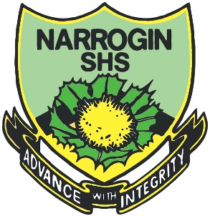

Year 7 Science 2019 Name: ____________

**Earth and Space 1 Test**

**SECTION 1: MULTIPLE CHOICE** (1 mark each)

Circle your answer on the separate answer sheet.

1. Our Sun’s **name** is
   1. Sol or Solaris.
   2. alpha Centauris.
   3. Milky Way.
   4. Jupiter.
2. Which of these statements about planets is **incorrect**?
   1. Planets orbit or revolve around the sun and rotate about their axis.
   2. Planets may be orbited by moons.
   3. All planets in our solar system rotate and revolve in the same direction and at the same speed.
   4. Planets may be made of rock or gas.
3. Which statement about the moon is **incorrect**?
   1. It takes the same time for the moon to complete one rotation as it does to revolve around the Earth, so we always see the same side of the moon.
   2. It takes about 21 days for the moon to revolve around the Earth.
   3. The phases of the moon are caused by the moon casting a shadow on itself.
   4. The moon’s craters are caused by meteorite impacts, as the moon has no atmosphere to deflect them.
4. The **device** that may be used to look at the moon is called
   1. a microscope.
   2. a telegraph.
   3. a telescope.
   4. a space probe.
5. Which is the **correct order** from smallest to largest?
   1. The Sun, The Moon, Earth, Jupiter
   2. The Moon, The Sun, Earth, Jupiter
   3. The Moon, The Earth, Jupiter, The Sun
   4. The Moon, Jupiter, The Earth, The Sun
6. The moon has **less gravity** than the Earth because
   1. it revolves faster.
   2. it is smaller in mass.
   3. it spins slower.
   4. it has less atmosphere.
7. **Space objects** that are smaller than planets, have irregular orbits and may form tails as they move past the sun are called
   1. Asteroids
   2. Meteorites
   3. Comets
   4. Moons
8. Which statement about meteorites is **false**?
   1. They are also called shooting stars.
   2. They burn brightly as they enter our atmosphere.
   3. They are very rare in Earth’s atmosphere.
   4. If they hit the ground they make craters.
9. Which of these is **not** a field of science?
   1. Astronomy
   2. Astrology
   3. Geology
   4. Chemistry
10. Orion, “The Hunter” is shown below.

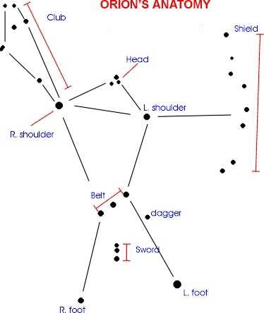

Orion is an **example** of

* 1. a star.
  2. a galaxy.
  3. an asteroid.
  4. a constellation.

**2019 Year 7 Science EES 1 Topic Test Answer Sheet**

**Name: ________________**

**Section 1: Multiple Choice Section**

Circle your selection. Make it clear to the marker what your selection is.

1. A B C D
2. A B C D
3. A B C D
4. A B C D
5. A B C D
6. A B C D
7. A B C D
8. A B C D
9. A B C D
10. A B C D

**M/C Marks: ______ / 10 marks**

**Section 2: Written Section**

Answer the following questions in the spaces provided:

1. Draw a labelled diagram to explain the difference between **rotation** and **revolution** of a planet. (4 marks)
2. Explain why at **midday** in Western Australia, it is **3pm** in Sydney. (4 marks)

________________________________________________________________

________________________________________________________________

________________________________________________________________

________________________________________________________________

1. Explain why it is **summer** in Australia when it is **winter** in Europe. (4 marks)

________________________________________________________________

________________________________________________________________

________________________________________________________________

________________________________________________________________

1. Draw a labelled diagram to show the Sun, Earth and Moon in a **solar eclipse**.

(3 marks)

**W/S Marks: ______ / 15 marks**

**TEST TOTAL: ________ / 25 marks**

**END OF TEST**